Andrew Graff

2231290

it6501

Assignment 2 – Part B (Analysis Design and Modelling)

Dr Steve McKinlay

**Executive Summary**

***The contents of this report reflect the design phase of our project Predator Free 2024 application. We get an insight of the activity diagram, a fully developed sequenced diagram and a specific development methodology to reflect these requirements. These three parts will share the steps involved in the application from a user perspective.***

**Activity Diagram**

**Application for the use case “Report Pest Sighting” showing interactions between a key stakeholder (environmentalist) and Pest application.**

**From login to acceptance of the pest report.**

**Describe the purpose of the activity diagram (1 sentence)**

**Describe model in 2-3 sentences and refer to your model in the text**

**Position the diagram after your explanatory text.**

Figure 3

Figure 2

Figure 1

**The purpose of this activity diagram is to show the flow of activities taking place in the Predator Free app involved in submitting a pest report.**

**As per activity diagram,**

**Figure 1:** We can identify the start node indicating the start of application by registering or logging into the Predator Free Application. We see the activities involved in the registration process.

**Figure 2:** Flow recording pest sighting information. Photo or no photo options, as well as other functions of input that take place in this duration.

**Figure 3:** Report submission and end of final node. Finalizing the end part or completed report submission.

**A fully developed sequence diagram for the app modelling the use case “Report Pest Sighting”**

1. **A computer screen shot of a computer

   Description automatically generatedAppropriate domain classes including controller classes**
2. **An actor**
3. **Activation lifelines**
4. **Method (function) calls with appropriate parameters**
5. **Messages (showing origins and destinations)**
6. **An appropriate title**
7. 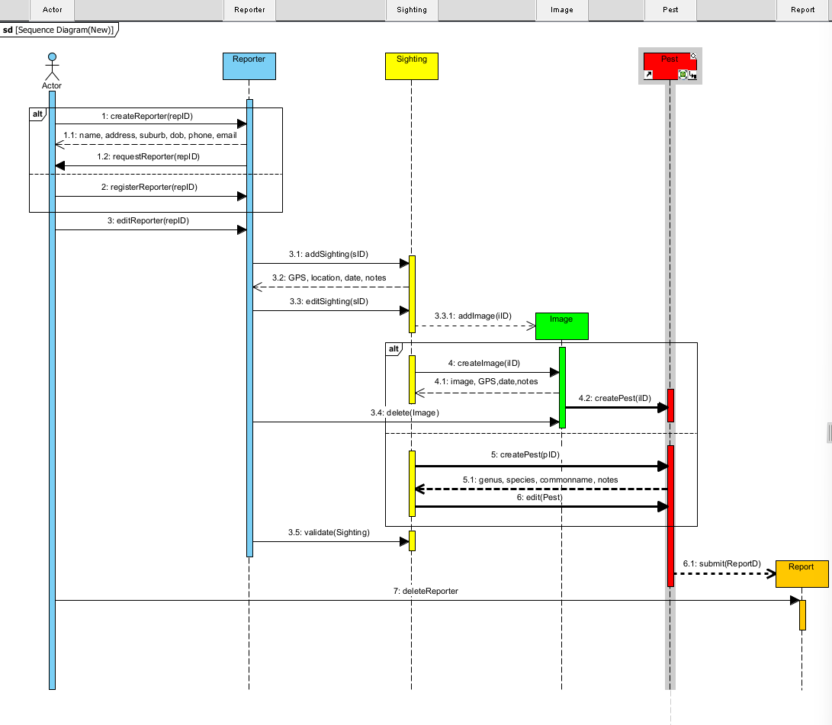**Any other notation or supporting information as required**

Here, we have a sequence diagram of the **PredatorFree 2024 Application** based off the case diagram.

We can see the sequence of events involved for the interactions taking place.

We are given four objects**: Reporter, Image, Sighting, and Pest**. Represented by the 4 activation lifelines showing the existence and next roll over sequence of the classes. (Report added as final call).

The two boxes are if/else; If no **ReporterID** then registering process takes place. This second box is shown if no **ImageID** (no image uploaded) then create **PestID** – enter notes etc.

First message when using the application for the first time is:

Create Reporter and return message to enter name, address, suburb, date of birth, phone and email. There is an edit Reporter function.

Second class is adding a Sighting once a **ReporterID** has been created. This returns a message asking for GPS, location, date and notes. There is an edit Sighting function.

Third class we have the option of adding an image, which is not compulsory, but an option is available. This returns a message requesting an image, GPS, date, notes. It allows to add an image or delete image.

Fourth class is the Pest, creating a **PestID** by entering genus, species, common name and notes. Option to edit Pest details. These can be done directly from Sighting without the requirement of fulfilling an image.

Lastly is submit Report, **Report ID** and options to delete Reporter which will delete Report.

The one specific system development methodology we will be using given the scale of the project, size of the team and the level of clarity in this project is **Waterfall**.

We have an experienced IT development unit team of 6 members. Four members who are highly skilled in programming and testing, and two in database and mobile user interface design. A crossover skill set with specialisation in mobile application development.

As per report, we have some planning prior around the analysis and design of the project using various methods. It is identified through consultation this project is a relatively small-scale, so with a team of high skills in programming and testing, our team members will compliment each other and are confident in providing a deliverable product.

Waterfall model project works in a chronological way consisting of 5 stages, Requirements, Design, Implementation, Verification and Maintenance. We have an oversight on requirements, design and implementation of the application. “It is also referred as a linear sequential life cycle model. It is very simple to understand and use”, Senarath, 2021). Our team will use these and gain clarity for what to build in the implementation and verification stages.

Each team member opted to work independently as the individual requirements were understood by each member. This largely incorporates the reasoning for selecting the Waterfall methodology. Clear objectives of the project are provided with supported models to use (*case models, activity diagrams, sequence diagrams etc*). “A structured approach to a project means that everyone understands what needs to be done and when (Gallagher et al, 2019).”

Requirements have been listed through our functional and non-functional needs, prototype sketches of our Design, ERD diagram establishing the relationships between the classes in our project, use case models, sequence diagram.

This leaves the final three stages of implementation, verification and maintenance. Our programmers, software developers and testers are prepared for this and will commence this as each stage progresses.

**References**

|  |  |
| --- | --- |
| (Gallagher et al, 2019) | Gallagher, A., Dunleavy, J., Reeves P. (2019). The Waterfall Model.  [The Waterfall Model: Advantages, disadvantages, and when you should use it - IBM Developer](https://developer.ibm.com/articles/waterfall-model-advantages-disadvantages/) |
| (Khwuta et al, 2023) | Khwuta , Y. D. D. Y. ., Londa , M. A. ., & Wee, Y. A. (2023). Designing and building a business data collection application using the waterfall method. *Matrix : Jurnal Manajemen Teknologi Dan Informatika*, *13*(1), 42–51. <https://doi.org/10.31940/matrix.v13i1.42-51> |
| (Senarath, 2021) | Senarath, U. S. (2021). Waterfall methodology, prototyping and agile development. *Tech. Rep.*, 1-16. |